**LAMPIRAN A**

**KETERANGAN TABEL 2**

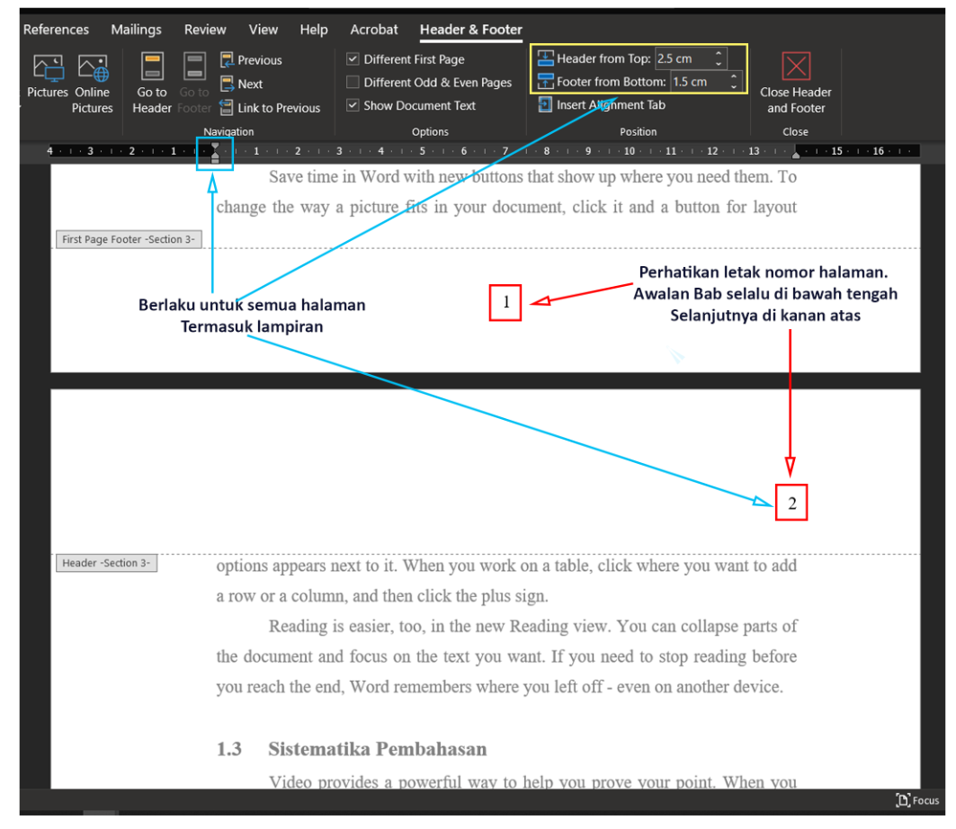

**Gambar A.1**

**Pengaturan Header dan Footer serta Nomor Halaman**

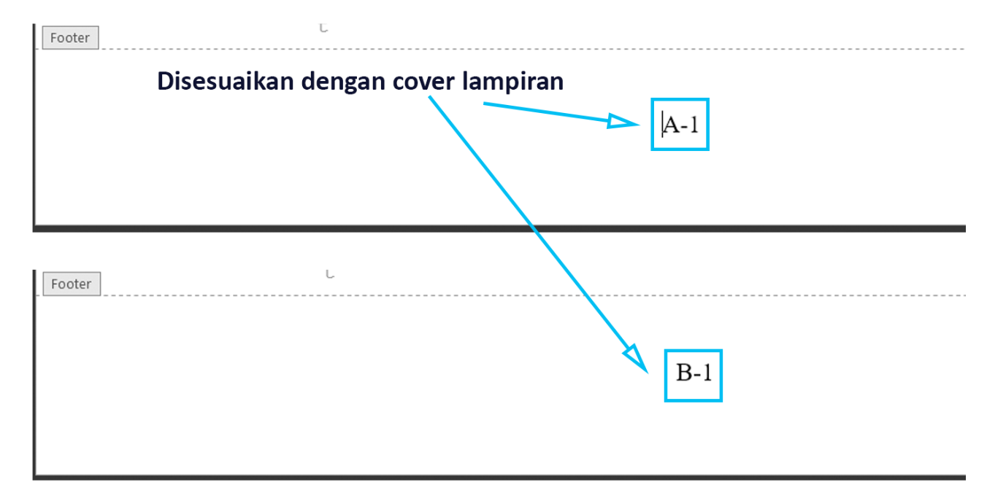

**Gambar A.2**

**Format Nomor Halaman Lampiran**

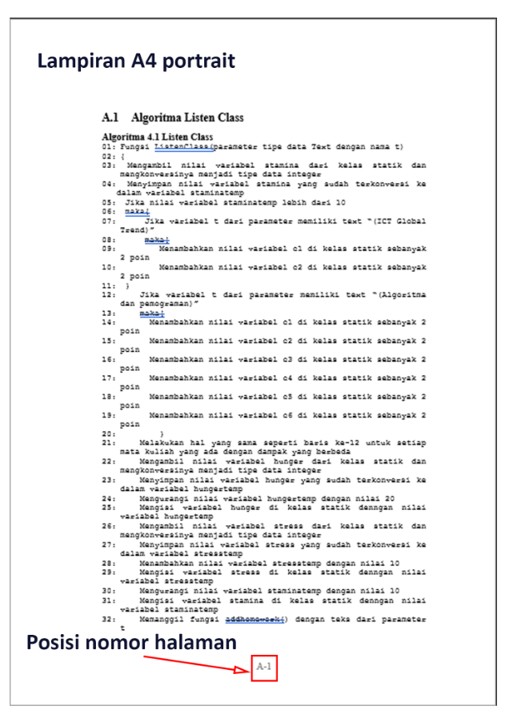

**Gambar A.3**

**Format Nomor Halaman Lampiran A4 Portrait**

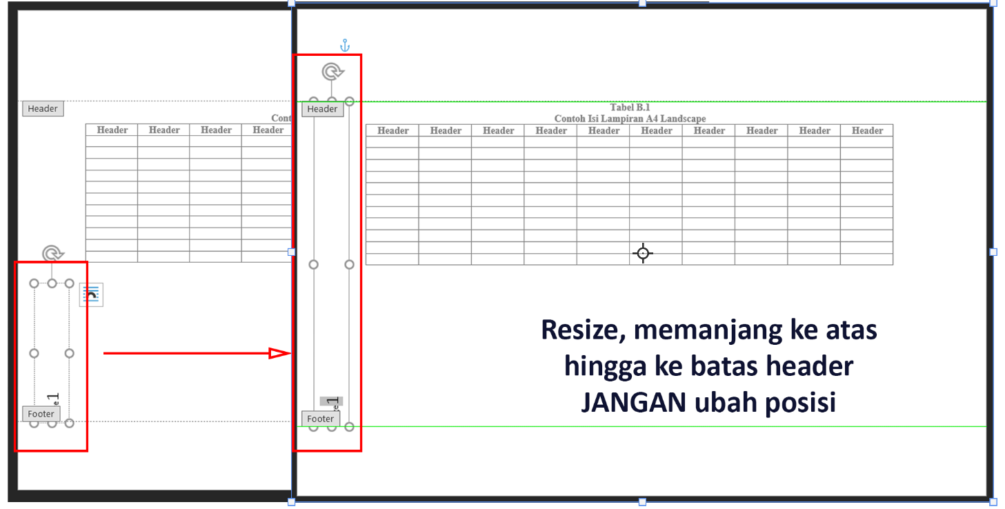

**Gambar A.4**

**Format Nomor Halaman Lampiran A4 Landscape Step 1**

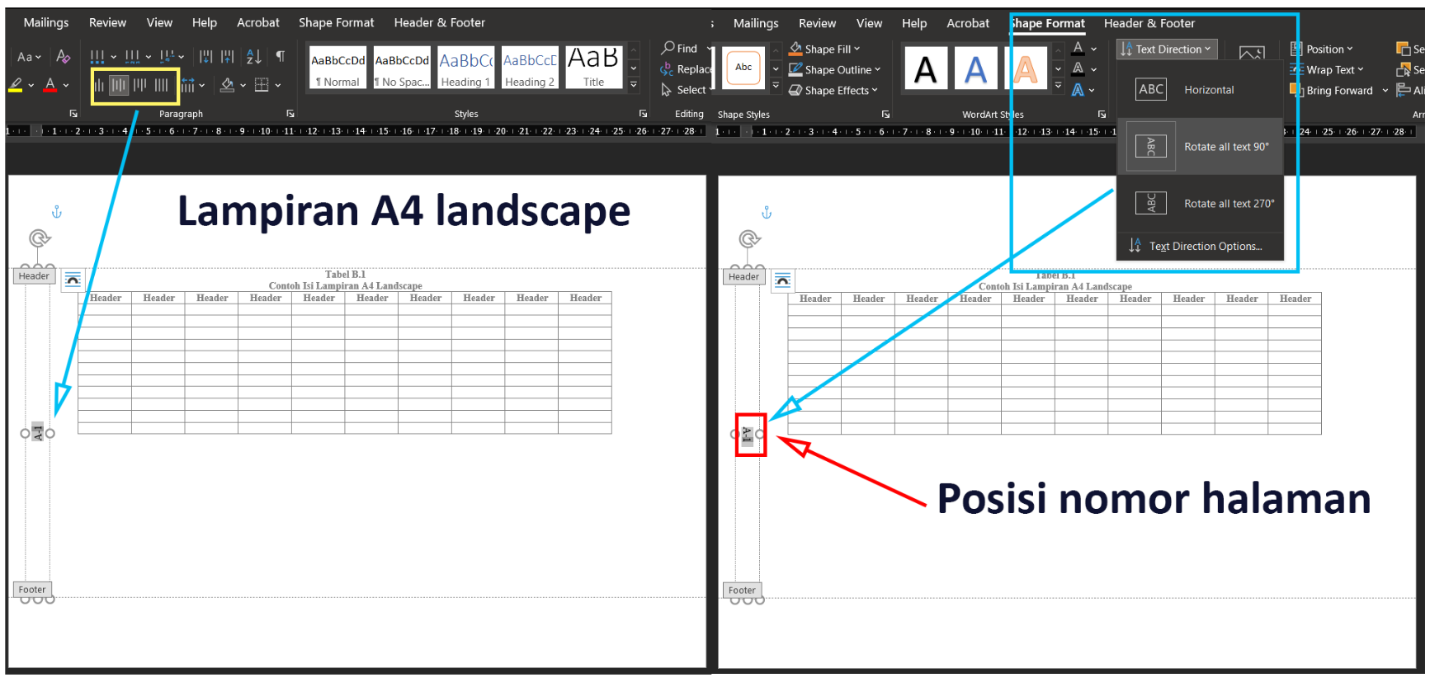

**Gambar A.5**

**Format Nomor Halaman Lampiran A4 Landscape Step 2**

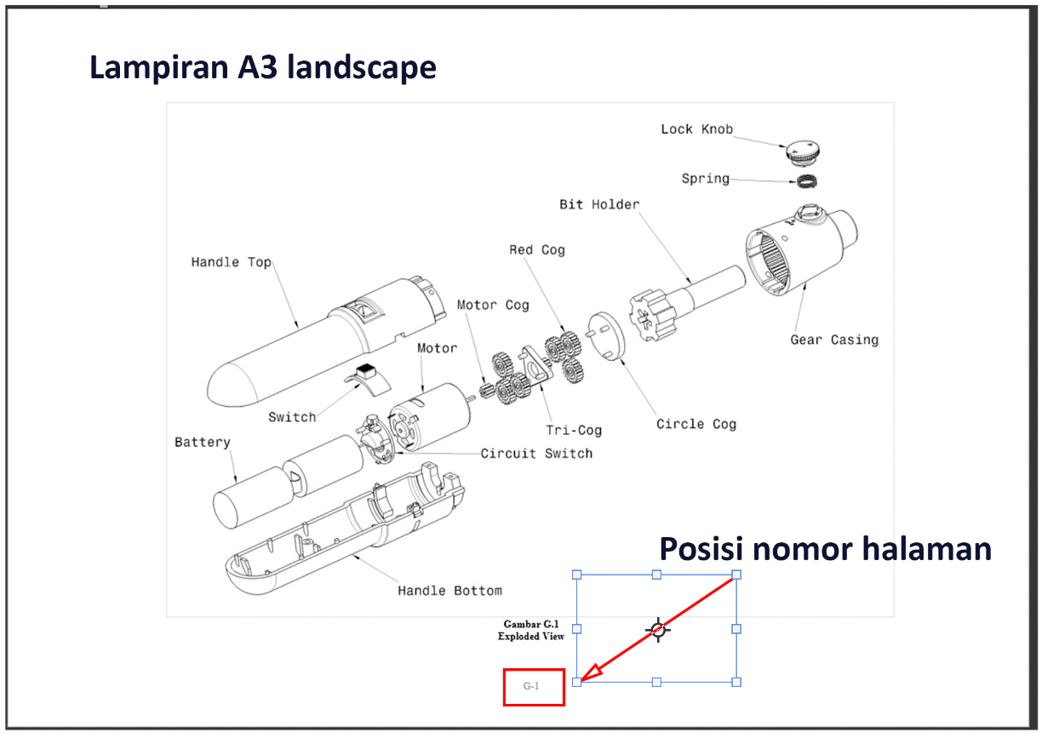

**Gambar A.6**

**Format Nomor Halaman Lampiran A3 Landscape**